Chapter 3, Problem 76.

Use PSpice to solve Prob. 3.27.

Chapter 3, Problem 27

Use nodal analysis to determine voltages v₁, v₂, and v₃ in the circuit in Fig. 3.76.

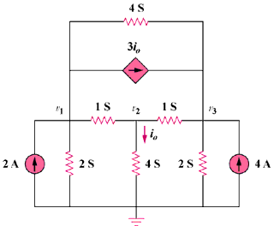

Figure 3.76
For Prob. 3.76.

